Name: Arpit Mahalle
React Assignment Day 10 screenshots:

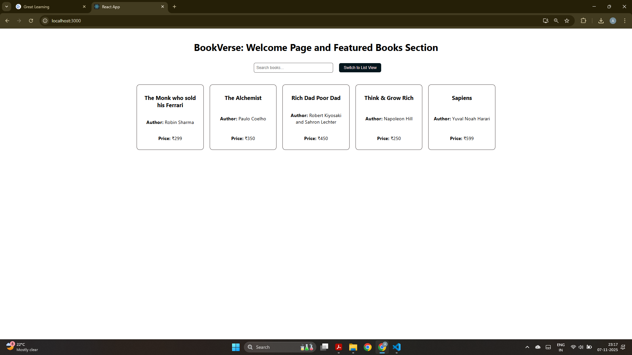
Welcome page of BookVerse react app which shows list of featured books on the home page.

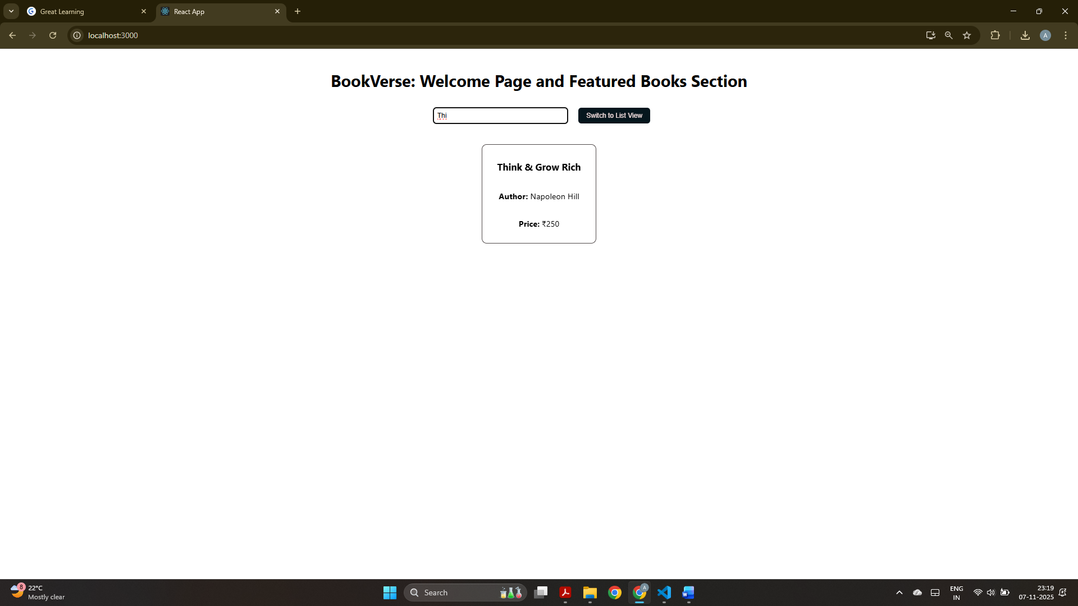
A simple search input box that filters the displayed books.

List view mode.

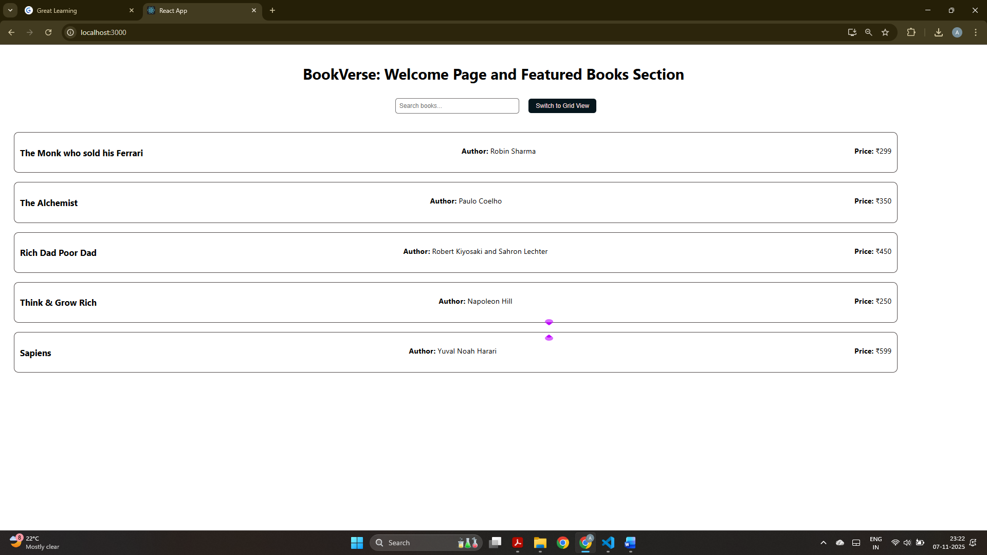
Grid view mode.

